BBT –Submission and Connection Management tool

Produced by
Thesaurus Maintenance Working Group,
VCC3, DARIAH EU

Version 1.3 (draft)
Status: working document

March 2017
(last update: 29/03/2017)

Contributors: Christos Georgis, Martin Doerr, Evagelia Daskalaki, Ilias Tzortzakakis, Chryssoula Bekiari

Table of Contents
Table of Contents 2
Introduction 3
1 BBT - Submission and Connection Management tool 4
1.1 Users 4
1.2 System functionality 5
1.2.1 Navigate the BBT and its versions 5
1.2.2 Linking/connecting local thesauri concepts to BBT concepts. 5
1.2.3 Receive and maintain suggestions on the BBT 6
1.2.4 Notifications about BBT releases 7
1.2.5 Integration with external systems 8
1.3 User actions 8
1.3.1 Contributor actions 8
1.3.2 BBT-curator actions 9
1.3.3 Reviewers actions 9
1.3.4 Administrator actions 9
1.4 Submissions 9
1.4.1 Submission workflow 9
1.4.2 Submission status 11
1.5 Screenshots (old interface) 12
1.6 Implementation details 15
1.6.1 System Architecture 15
1.6.2 System Platform 16
1.7 System Demonstrator 16

Introduction

In the report “A model for sustainable interoperable thesauri maintenance” , it is proposed a coherent overarching thesaurus for the humanities, a “backbone” or “metathesaurus”, under which all the vocabularies and terminologies in use in the domain can be aligned. The proposed approach is bottom-up; top-level concepts are developed by adequate abstraction from existing local terminological systems.
In the design report "Assisting Backbone Thesaurus maintenance”, we describe how to support all the stakeholders in this endeavor, by proposing a maintenance methodology, along with an assisting toolset that:
- enables independent local thesauri maintainers to create and maintain their thesauri, and at the same time incorporate them while still maintaining their independence, into a shared common thesaurus, that will be available to the public,
- enables the BBT curators of this common scheme of abstract concepts (hereafter BackBone Thesaurus, or BBT), to support and maintain the BBT, as a central thesaurus which would provide the general concepts under which local thesauri maintainers can attach/link their thesauri, and
- enables potential users (public, scientific community, etc.) to browse, navigate, visualize and use this very rich thesaurus that would incorporate the wealth of the different thesauri.
This document describes the methodology and tool (Submission and Connection Management tool) that enables independent local thesauri maintainers and potential BBT users (public, scientific community, etc.) to propose to the BBT curators new BBT concepts or modifications on the BBT existing concepts, as well as assists local thesauri maintainers to use and link/connect their thesauri to BBT.

BBT - Submission and Connection Management tool
The BBT Submission and Connection Management tool is a communication system, developed by FORTH-ICS (www.ics.forth.gr), that supports discussions regarding the changes proposed for the BBT (changes related to concepts and their relations), hereafter called submissions. It keeps track of the different versions of the BBT and the history of the submissions (related past discussions). It also notifies all the interested parties, about the progress of a submission, and the release of the new versions of the BBT.
The BBT Submission and Connection Management tool is used by local thesauri maintainers when they want to suggest changes for the BBT (contributors); it provides a form by which they can request modifications/additions/deletions regarding the concepts of the thesaurus. The tool is also used by the BBT-curators to browse and review submissions, and decide whether they agree to the suggested changes or disagree and ignore/reject/postpone them. The system also provides access to the previous versions of the thesaurus and the history of all the submissions in order to facilitate BBT-curator's job. The BBT-curators may also forward a submission to users that are experts in specific domains (Reviewers), for further consultation. Finally, the tool is used by thesaurus Reviewers that take part on specific change-related discussions.
The BBT Submission and Connection Management tool also assists local thesauri maintainers to use and link their thesauri to BBT. As mentioned earlier publishing a new version of the BBT may also affect the local thesauri that are linked to BBT, therefore local thesauri maintainers need to be notified. The system provides (a) a service for creating (and removing) links originating from BBT concepts to local thesauri concepts (LOD identified), (b) a storage for contact info, along with (c) a notification mechanism that enables local thesauri maintainers to receive information on BBT new releases.

Users
The BBT Submission and Connection Management tool can be accessed only with a valid username and password pair. Depending on the user’s role, he/she will have different rights. The different user-roles of the system are:
- Contributors (local thesauri maintainers or BBT-curators): The contributors are the persons who wish to comment or suggest changes on the BBT, requesting additions, deletions or modifications on the BBT concepts and their relations. The contributors submit requests for changes. Especially local thesauri maintainers may also wish to link their local thesauri concepts to concepts in the BBT.
- BBT-curators: The BBT-curators are responsible for the maintenance of the BBT model. Their role is to make changes to the thesaurus model by consulting the submissions concerning the current thesaurus and the previous versions of the thesaurus. The BBT-curators have also the role of contributors: they can insert their own submissions into the system. Submissions can be forwarded to the thesaurus Reviewers to be reviewed. They may also request clarification on a request from a contributor, or request the opinion of thesaurus Reviewers regarding specific change request.
- Reviewers: The Reviewers review submissions made or forwarded by the BBT-curators that are pertinent to their expertise (domain of knowledge), and respond back to the BBT-curators with proposed changes to the BBT.
- System Administrators: The System Administrators are responsible for the maintenance of the system information and the system software: manage the new users into the system, take and restore backups, etc.
The system provides a sign-in functionality, which enables anyone to login only providing minimum communication information. The sign-in is verified by an e-mail acknowledgement mechanism. Signed-in users get the role of contributor; to get a different role the user should contact systems administrator.

System functionality
The system provides navigation on the BBT and its versions, enables the linking/connection of local thesauri concepts to BBT concepts, receives suggestions on possible changes in the BBT concepts, while supporting the discussion on the suggestions and finally provides notifications about BBT releases on all the involved parties/users of the BBT.

Navigate the BBT and its versions
The BBT Submission and Connection Management tool provides browsing and navigation on the BBT concepts. It provides search forms that enables search on concept information. The user can navigate the thesaurus by moving from concept to concept while is able from a single form to access the related submissions made for this specific concept, all connected-concepts from external thesauri to this specific concept and the concepts version history.

Linking/connecting local thesauri concepts to BBT concepts.
Local thesauri maintainers create their own local thesauri, using their own workflow and software. We encourage local thesaurus maintainers to use concepts from BBT as top-concepts in their thesauri. This will enable the alignment of their vocabularies and terminologies (thesauri) under one shared thesaurus, the BBT.
The first step in linking/connecting local thesauri with the BBT in general means deciding which of the upper level concepts of the local thesauri should be classified under the general concepts of the BBT. We propose, that local thesauri maintainers should include in their local thesauri general BBT concepts, by using local concepts (declared as “same as”/“exact equivalence” or “narrower of” to the BBT concepts, by their LOD identifiers as these are provided by the BBT Access Service). This would constitute a one-direction link from the local thesaurus to the BBT.
Additionally we propose the use of the BBT Submission and Connection Management tool to maintain a second link originating from the BBT concept to its connected concept in the local thesauri. The system provides a form which enables local thesaurus maintainers to create this link/connection (LOD identification of the local thesaurus concept which is declared as “same as” or “narrower of” the BBT concept). The system also stores contact information of the local thesauri maintainers in order to keep them updated for changes on the specific BBT concept (e.g. contact e-mail, organization info, etc.). This information is initially received during the user signing-in phase and can be later updated by the user.
The BBT Submission and Connection Management tool also includes a service that notifies the local thesauri maintainers about changes in the new version of BBT that may affect them. For instance, if a BBT concept is modified (e.g. its scope note is updated, thus its meaning is altered), all local thesauri developed that are linked/connected to the specific BBT concept as a top-concepts in their thesauri, should be notified about the change in order to verify if the specific change affects their local thesauri.
Local thesauri maintainers may also decide to un-link their thesauri from BBT. For that, they should remove the local links/connections declared as “same as” or “narrower” to the BBT concepts (removal of the one-direction link from the local thesaurus to the BBT). Additionally they should use the BBT Submission and Connection Management tool to remove the link/connection originating from the BBT concept to its cone cted concept in the local thesauri (and maybe would also remove the related local thesauri maintainers contact information).

Receive and maintain suggestions on the BBT
The BBT Submission and Connection Management tool also receives requests (submissions) from users who want to suggest changes on the BBT model (contributors) and assists the BBT-curators in making decisions about these requests, by providing full version control on the BBT and on the submissions. It provides access to the current state of the thesaurus, all BBT previous versions, maintaining all their differences from version to version and finally provides access the history of all submissions.
It provides contributors with forms for sending requests for modifications/additions/deletions on specific concepts or specific relations of the BBT model. The BBT-curators can browse through the submissions, review them and decide whether they agree to accept the suggested change or disagree and ignore/reject/postpone the change. To assist them in making their decisions the system provides the previous versions of the thesaurus and the history of all the submissions ever made in order to facilitate the work of BBT-curators. Figure 1, below, shows the Use Case diagram for the Submission. The submission workflow and coordination is described in detail in section 1.4.1.
The BBT-curators use the BBT management tool to implement the actual changes in the thesaurus database. After several minor or few major changes of the BBT model, a release of the BBT may be decided by the BBT-curators.
As a new version is created, all changes between the new and the previous version of the thesaurus are semi-automatically tracked (some of the changes may need to be manually identified by the BBT-curator). Now all past submissions follow the current version of the BBT. The mechanism described above enables the system to provide access to the previous versions of the thesaurus, the differences between versions and the history of all the submissions.
The BBT Submission and Connection Management tool provides contributors with automatic feedback (in form of notifications) regarding the status of their submission and the status of the BBT: a new version of the thesaurus (a submission is made) is about to be (or is) released.
The system also allows the communication with external tools through specific web service functionality. It is able to receive new submissions and return the differences between versions (e.g. two subsequent versions of the BBT, or the history of a concept, or relation). As described in section 1.2.5.
Figure 1: Use Case diagram for the Submission

Notifications about BBT releases
The BBT Submission and Connection Management tool includes a service that notifies the local thesauri maintainers about changes in the new version of BBT that may affect them. For instance, if a BBT concept is modified (e.g. its scope note is updated, thus its meaning is altered), all local thesauri developed that are linked/connected to the specific BBT concept as a top-concepts in their thesauri, should be notified about the change in order to verify if the specific change affects their local thesauri.
Furthermore, the system provides all contributors with automatic feedback (in form of notifications) regarding the status of their submission and the status of the BBT: a new version of the thesaurus (a submission-request is implemented) is about to be (or is) released.

Integration with external systems
The system is designed to support interaction with other external tools, by using web services technology, which allows the systems to communicate with each other without intimate knowledge of each other’s internal behaviour or technology.
The available functions that the system provides via web services are listed below:
- Add a new submission into the system
- Return the table of differences between two subsequent versions, as the BBT-curator has marked them
- Return the history of a concept (all the concept differences from version to version)
- (Not yet implemented: ) Receive a new BBT version and automatically load it into to the system.
Since this document works as a design document, we welcome any suggestions for added functionality or customizations on the existing one.

User actions
By using the BBT Submission and Connection Management tool the contributors are able to search for a concept or a relation in the BBT, make a critic on it and put a request for a change. The system stores the history of the dialogue between the contributors and the BBT-curators and inform all the interested parties when a change on the thesaurus has occurred or a new version of the thesaurus has been released. All the interested parties are kept up to date, by receiving e-mail from the system. Furthermore the system assists local thesauri maintainers to use and link their thesauri to BBT.
The functionalities of the system for each of the user-roles are the presented in the following sections.

Contributor actions
Contributors can:
- Search for a concept
- View a concept
- Create and delete a link/connection from a BBT concept to a local thesauri concept
- List all links/connections from BBT to all local thesauri
- Submit a request for change in the BBT model. The contributors can submit a request for adding, deleting, or modifying a concept in the BBT model. The system provides a form where the user has to fill in the following information: name, definition (scope notes), context of use, justification, and example.
- Search for a submission
- View a submission
- List pending explanation-requests
- View a pending explanation-request
- Reply to a pending explanation on a submission

BBT-curator actions
The BBT-curators are the only users who have the full “view” of the system: they have all the rights and permissions on the informational parts of the system. That means that he has all the functions available to the contributor as well as:
- View the history of a concept
- Send an explanation-request
- List pending or replied explanation-requests
- List all pending explanation-requests for reply
- Insert a new Version of the BBT history
- Request for an expert opinion on a submission to the Reviewer
- Request for clarification on a submission to a contributor
- Change the status of a submission

Reviewers actions
The Reviewers has the same functions as the contributor.

Administrator actions
- Manage the accounts
- System backup/restore

Submissions

Submission workflow
When inserting a new change request (submission) into the system the contributor receives automatic response that certifies the submission. Once this is done, the new submission is inserted into the system’s submission pool. Notifications on the new submissions are sent by e-mail to the BBT-curators, in order to inform them for the new change requests. Furthermore the BBT-curators can see the new submissions in the system by accessing a specific area (page) in their system workspace. The process that is followed after a new submission is described below:
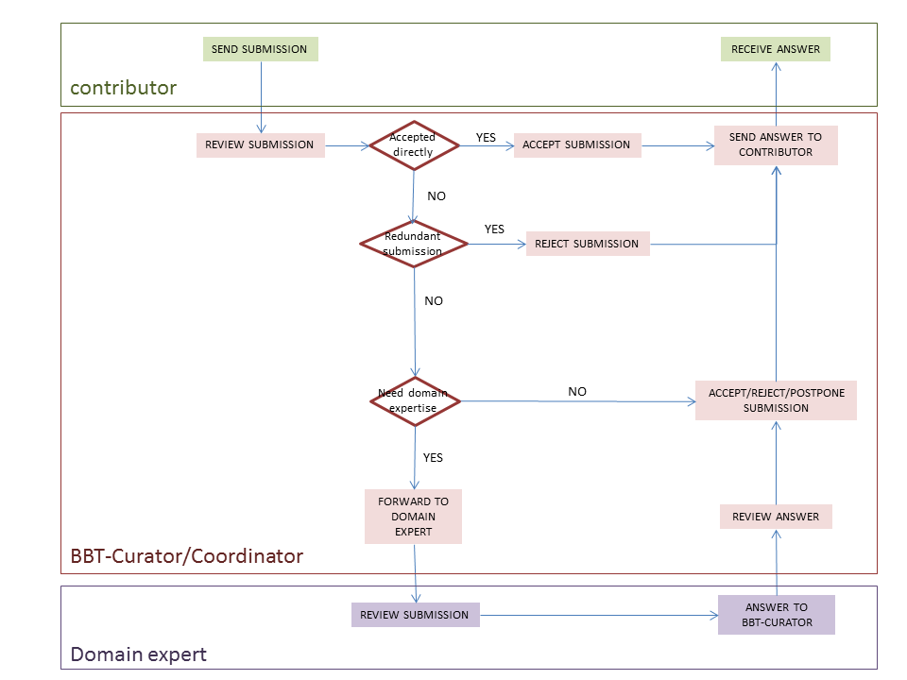
Figure 2: Activity Diagram of the submission workflow
When the new submission is inserted, the BBT-coordinating-curator may check whether the submission is redundant, or not, and initiate the discussion on the proposed change, by welcoming the other BBT-curators to review the new submission. If the submission is directly accepted, the BBT-coordinating-curator implements the change into the BBT database using the BBT Management Tool. Otherwise the submission is rejected, postponed or beyond BBT-curators’ expertise. If the BBT-curators consider that the submission is beyond their expertise, they may send it to the thesaurus Reviewers (invite him/her in the discussion). The Reviewer will be informed by e-mail for the submission. After the Reviewer checks the submission, he/she state his/her opinion on the change. The BBT-curators review the Reviewer’s answer, and again decide to accept, reject, or postpone the submission. In all cases the contributors are informed by e-mail about the progress of their submissions. In Figure 2, above, you can see the activity diagram of the submission workflow. Although it is not presented in the diagram, a discussion may contain many iterations of discussions. The BBT-coordinating-curator may end the discussion (e.g. concluding that a common agreement is reached or by asking a voting to take place, etc.). Once a decision on a change is made they are responsible to implement the change into the BBT database using the BBT Management Tool.
The BBT-curators are also responsible to decide upon the publication of a new version of BBT model: a new version of BBT may include several changes of the BBT. In order for an official version of the BBT model to be released, the BBT-curators use the BBT Management Tool to implement any pending changes in the thesaurus database. Then they export official version of the BBT model from the BBT Management Tool in two forms: the BBT Definition Document (the official textual description of the BBT model) and the BBT LOD model (a SKOS RDF document). The new version of BBT LOD model should be sent to the BBT – Thesaurus Access tool to be loaded and to be publicly accessible (by the BBT access providers).

Submission status
Submissions have statuses that can be changed by the selected user actions. They are listed below (see also Figure 3):
- Submitted (pending): It is the first status of a change request. Once the contributor sends a submission it takes the status “Submitted”. This status shows that the submission has not been checked from the BBT-curator.
- Under discussion, wait for reply: After the submission the BBT-coordinating-curator checks the submission, he might need some explanations or even more information about the submission. If that is the case, then he sends a submission back to the contributor and the submission is taking the status “Under discussion, wait for reply”.
- Under discussion, replied: The contributor reviews the received submissions and replies giving explanations or more information about the submission. The submission gets the status “Under discussion, replied”.
- Implementation: When a submission has the status “Implementation”, it means that the BBT-coordinating-curator is introducing the change into the thesaurus database using the BBT Management Tool.
- Wait for release: After the BBT-coordinating-curator introduced the into the thesaurus database, he/she changes the submission status to “Wait for release”. During this phase, changes may still occur to the submission until it comes to its final state.
- Released: A new official version of the BBT model is released, all submissions with status “Wait for release” change to “Released” and all the interested parties have been informed about the final status of the request for change.
- Postponed: The request for change will be reviewed later in time.
- Rejected: The request for change is considered as not implementable or implementable in the future, and all the parties are informed.
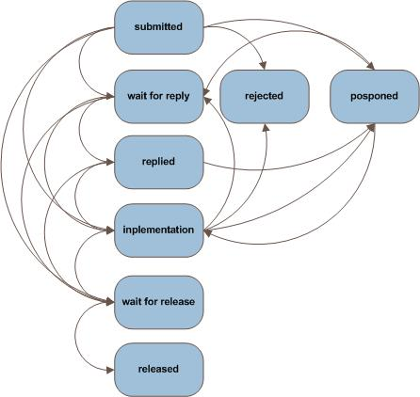
Figure 3: Sequence Diagram, of the submission statuses.

Screenshots (old interface)
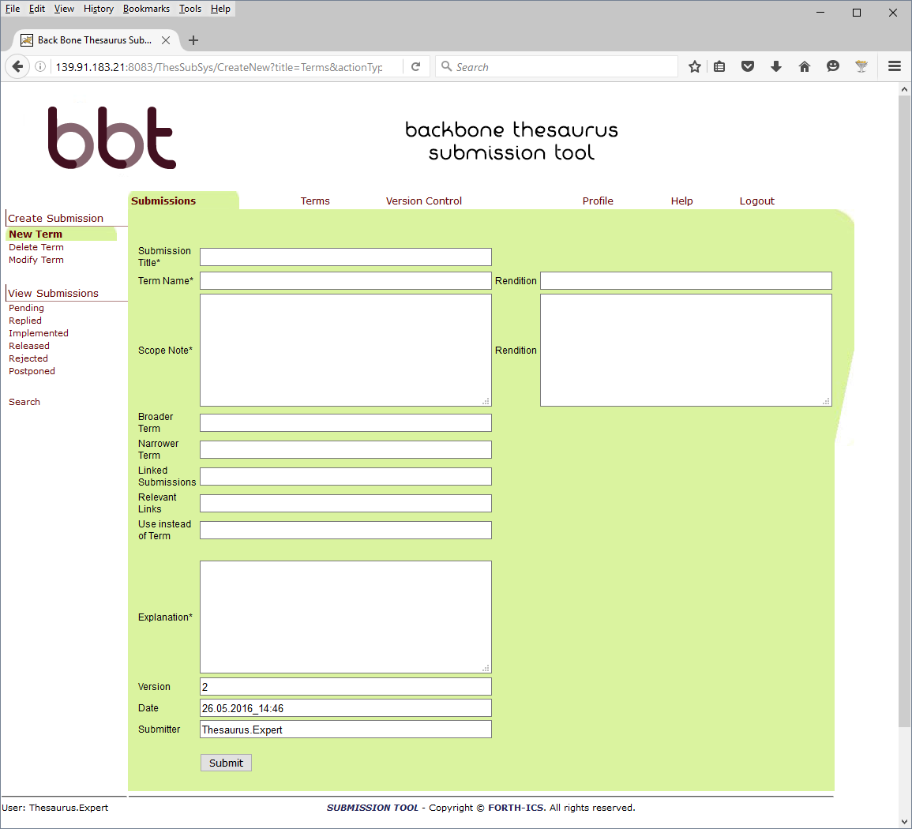
Figure 4: Make a submission to create a New BBT Concept (New Term)
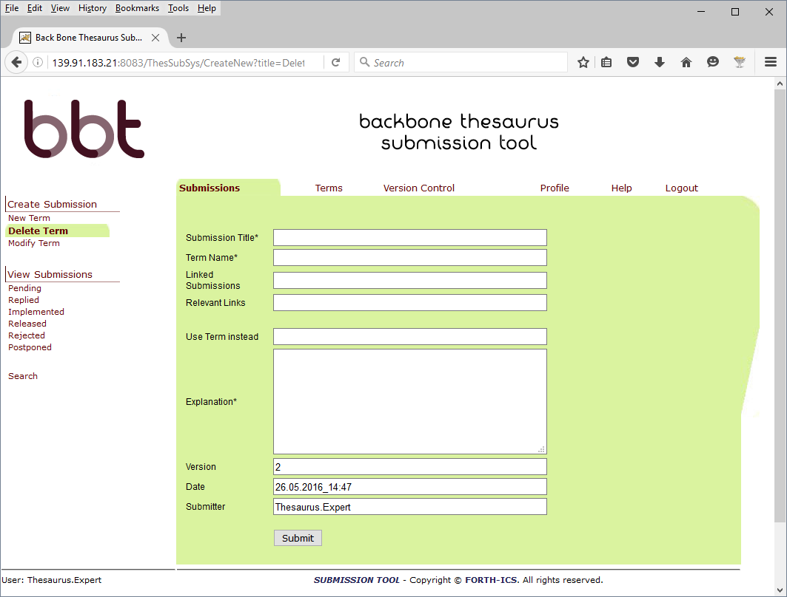
Figure 5: Make a submission to delete a BBT Concept (Delete Term)

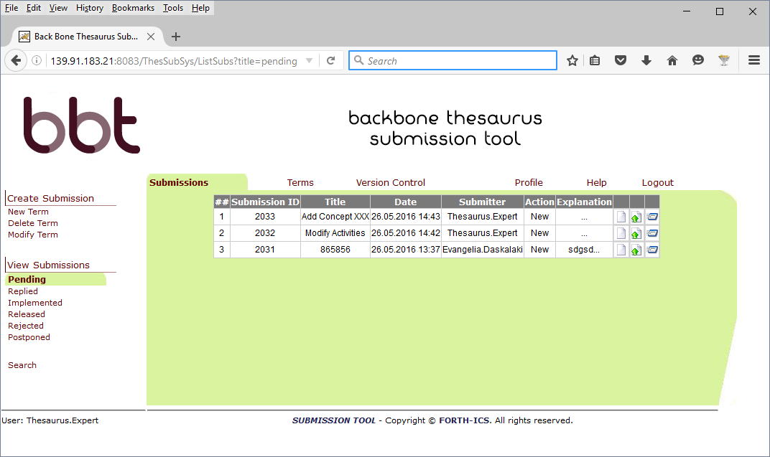
Figure 6: List all pending submissions

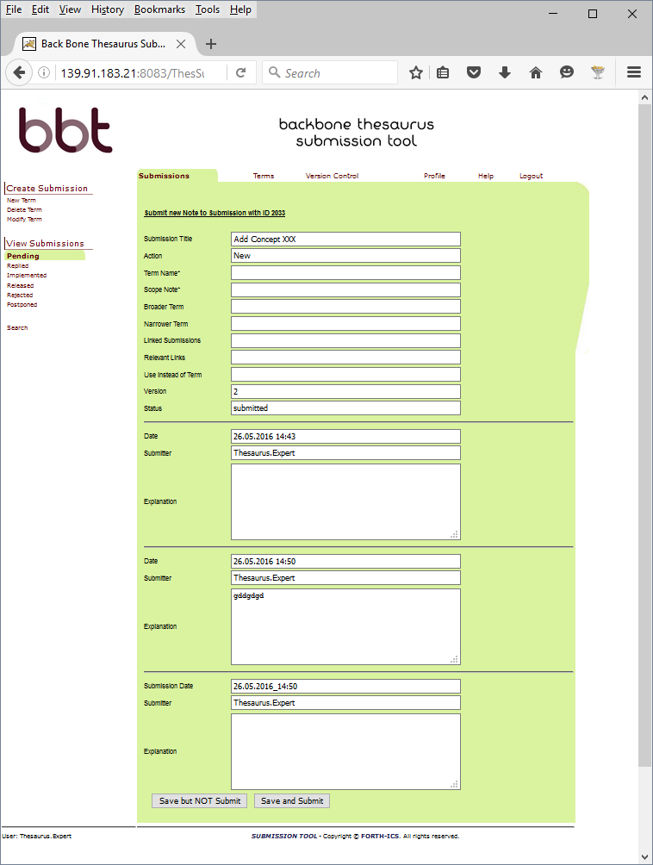Figure 7: View a submission history

Implementation details

System Architecture
The system is developed on a 3-tier architecture, which allows us to create a modular code that can be easily maintained and expanded.
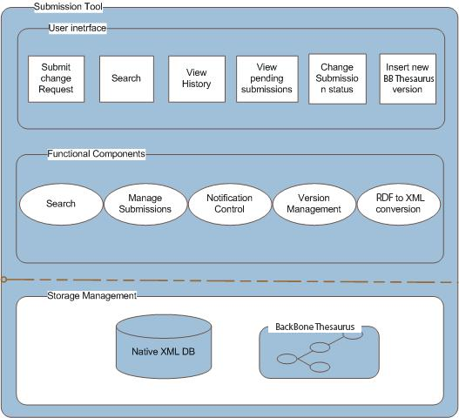
Figure 8: System Architecture
Storage management
The storage management module includes a XML Database where all the converted XML documents, the XML submission files as well as the configuration files for the users, the permissions, the Queries and all the versions of the BBT are stored. Each version of the BBT includes the thesaurus information in an RDF (SKOS) document. The system contains a copy of the current state of the thesaurus (the thesaurus, a SKOS RDF document, is digested into the system in form of XML file(s), containing the description of concepts and relations between concepts).
User interface
The user interface includes the interaction components that contributors, BBT-curators and Reviewers use for the change requests, along with change-request reviewing and thesaurus versioning reviewing and the search. Notice that the actions provided to the users depend on the users’ role. This front-end of the system provides users with clear view of the operations available for the specific documentation stage. The system’s functionality is invoked with simple user actions, such as button selections etc.
Functional components
The functional components constitute the basic mechanism that incorporates all the system’s intelligence. It includes various functional modules such as the search mechanism for the submissions, search mechanism for the Concepts, the mechanism for adding a new submission, the permissions management component, the notification control mechanism, the version Management component, the RDF to XML conversion module, etc. These modules are invoked by user actions or through the interaction with other modules and react with the storage mechanism.

System Platform
Web Application Server and Web-browser
The Submission and Connection Management tool is a web based on-line application, which is based on client-server architecture. As mentioned earlier, the system is developed using J2EE technology, on a 3-tier architecture, which allows us to create modular code that can be easily maintained and expanded. It is accessible to every user who owns a login account. The only prerequisites for using the tool are access to the World Wide Web (Internet) and a Web Browser (e.g. Internet Explorer, Mozilla Firefox, etc.).
Database
The system Database stores XML documents that have been produced from the conversion of the RDF (SKOS) document, the XML submission documents that include all the history of the concepts of the BBT, the requests for changes, as well as the stored Queries for the users, the configuration files for the user permissions etc.
We have chosen eXist Native XML DB, as our system database. The choice has been made based on the following criteria: documentation, reputation, encoding support, interface capability with other systems, as well as the cost (open source).
Operating system
The Submission and Connection Management tool Application Server is developed and operated on a Windows Operating system, but we expect to run smoothly on any operating system since the underlying technologies are running on any operating system.

System Demonstrator
- Web Application http://139.91.183.44:8013/ThesSubSys
For login details please contact georgis@ics.forth.gr or bekiari@ics.forth.gr

“A model for sustainable interoperable thesauri maintenance”, produced by Thesaurus Maintenance Working Group, VCC3, DARIAH EU, Version 1.1, January 2016, (http://83.212.168.219/DariahCrete/sites/default/files/dariah_bbt_v_1.1.pdf)
Note that the BBT Submission and Connection Management tool does not replace the BBT Access Service, which is responsible for hosting and providing the web-presence and LOD access to the current version the BBT.
This linking/connection of the local thesaurus with the BBT is performed only by the local thesaurus maintainers using their own thesaurus maintenance workflow and software.
If the list of the possible changes of concepts is not fully defined we welcome any suggestions to complete it.

